# MODULE 3 UNIT 3

## Ongoing project

Learning outcome:

LO4: Recommend sensemaking and relating approaches to address a specific challenge or opportunity.

### Name:

#### 1. Instructions and guidelines (Read carefully)

##### Instructions

1. Insert your name and surname in the space provided above, as well as in the **file name.** Save the file as: **First name Surname M3 U3 Ongoing Project** – **e.g., Lilly Smith M3 U3 Ongoing Project.** **NB:** *Please ensure that you use the name that appears in your participant profile on the Online Campus.*

2. Write all your answers in this document. There is an instruction that says, “Start writing here” under each question. Please type your answer there. You are also provided with a table in Question 1. Please populate this table according to the provided instructions.

3. Submit your assignment in **Microsoft Word only**. No other file types will be accepted.

4. Do **not delete the plagiarism declaration** or the **assignment instructions and guidelines**. They must remain in your assignment when you submit.

**PLEASE NOTE:** **Plagiarism cases will be investigated in line with the Terms and Conditions for Participants.**

IMPORTANT NOTICE: Please ensure that you have checked your program calendar for the due date for this assignment.

##### Guidelines

1. There are 8 pages and 2 questions in this assignment.

2. Make sure that you have carefully read and fully understood the questions before answering them. Answer the questions fully but concisely and as directly as possible. Follow all specific instructions for individual questions (e.g., “list,” “in point form”).

3. Answer all questions in your own words. Do not copy any text from the notes, readings, or other sources. **The assignment must be your own work only.**

|  |
| --- |
| **Plagiarism declaration:** |
| **1. I know that plagiarism is wrong. Plagiarism is to use another’s work and pretend that it is one’s own.**  **2. This assignment is my own work.**  **3. I have not allowed, and will not allow, anyone to copy my work with the intention of passing it off as his or her own work.**  **4. I acknowledge that copying someone else’s assignment (or part of it) is wrong, and declare that my assignments are my own work.** |

#### 2. Questions

In the Module 1 ongoing project, you selected an organizational challenge or opportunity that you wish to address using the 4-CAPS+ Leadership Framework. In Modules 2 and 3, you explored the capabilities of sensemaking and relating.

In this ongoing project, you will use your knowledge to decide how to engage in sensemaking and relating for your selected organizational challenge or opportunity. Answer the questions that follow, using your selected organizational challenge or opportunity as the basis of your submission.

##### Question 1

Module 1 emphasized that no leader can exhibit all the capabilities in the 4-CAPS+ Leadership Framework, and that it is important to recognize where your particular strengths lie to determine the sub-dimensions in which you can take the lead.

In Modules 2 and 3, you learned about the sub-dimensions of sensemaking and relating. This question requires you to categorize your leadership skills in terms of these sub-dimensions. While all the sub-dimensions will be important to enact, some may be more relevant to your specific context. As such, your answer should also indicate the relevance of each sensemaking and relating sub-dimension in relation to your selected organizational challenge or opportunity.

Table 1 lists the sub-dimensions of sensemaking and relating. Use the drop-down menu in the first column of the table to select your skill level in each. Figure 1 provides you with guidelines for categorizing your skill level.

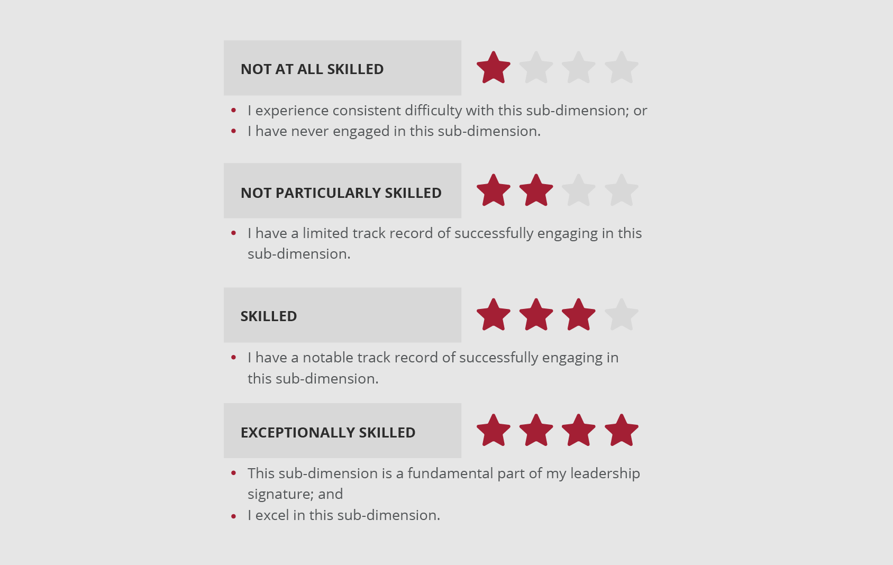

**Figure 1:** Guidelines for categorizing your skill level in a sub-dimension.

When making your selection, think carefully about how you, as a leader, have engaged in each sub-dimension. Be honest with yourself about your skills – identifying your strengths and weaknesses will help you to better decide how to address your selected organizational challenge or opportunity.

Next, use the drop-down menu in the second column of the table to rate how relevant each sub-dimension is for your selected organizational challenge or opportunity. Figure 2 provides you with guidelines for rating the relevance of a sub-dimension.

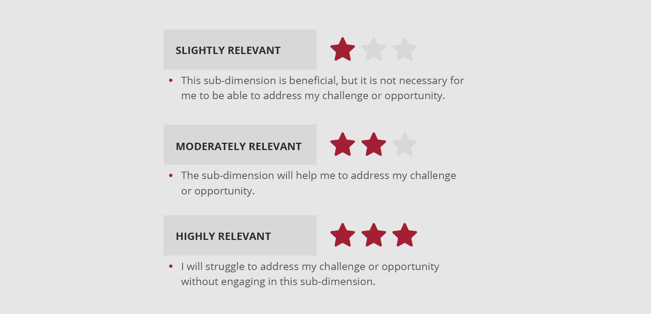

**Figure 2:** Guidelines for rating the relevance of a sub-dimension.

When making your selection, think carefully about the specific characteristics of each sub-dimension to help you rate its relevance for your selected organizational challenge or opportunity.

Populate Table 1.

**Table 1:** Categorize your skills and rate the relevance of each sub-dimension.

|  |  |  |
| --- | --- | --- |
| **Sub-dimension** | **Skill level** | **Relevance** |
| Sensemaking: Open-mindedness | Skilled | Slightly relevant |
| Sensemaking: Learning from others | Skilled | Moderately relevant |
| Sensemaking: Creating meaning in uncertainty | Skilled | Highly relevant |
| Sensemaking: Experimenting | Skilled | Highly relevant |
| Relating: Inquiring | Skilled | Highly relevant |
| Relating: Influencing and negotiating | Not at all skilled | Highly relevant |
| Relating: Supporting and coaching | Not particularly skilled | Highly relevant |
| Relating: Connecting outside | Skilled | Slightly relevant |

##### Question 2

Consider how you can use the capabilities of sensemaking and relating to address your selected organizational challenge or opportunity.

While you may be able to take the lead in the sub-dimensions in which you are more skilled, you may need to reach out to others for the sub-dimensions in which you are less skilled. Keep your responses in Question 1 in mind as you answer Questions 2.1 and 2.2.

###### Question 2.1

How can you take the lead in terms of sensemaking and relating for your selected organizational challenge or opportunity? In your answer, consider the following criteria:

* Reiterate what your selected organizational challenge or opportunity entails.
* Consider where your strengths lie in terms of the sub-dimensions of sensemaking and relating.
* Review which sub-dimensions are relevant for your selected organizational challenge or opportunity.
* Based on the above considerations, explain how you can engage in sensemaking and relating for your selected organizational challenge or opportunity.
* Be specific: What will you actually do next week, next month, and next year in order to engage in sensemaking and relating?

(200–250 words)

Start writing here:

My organizational challenge is to influence the digital technology team at GE BioPharma to collaboratively research, define and share our 2020 digital marketing vision and roadmap[1].

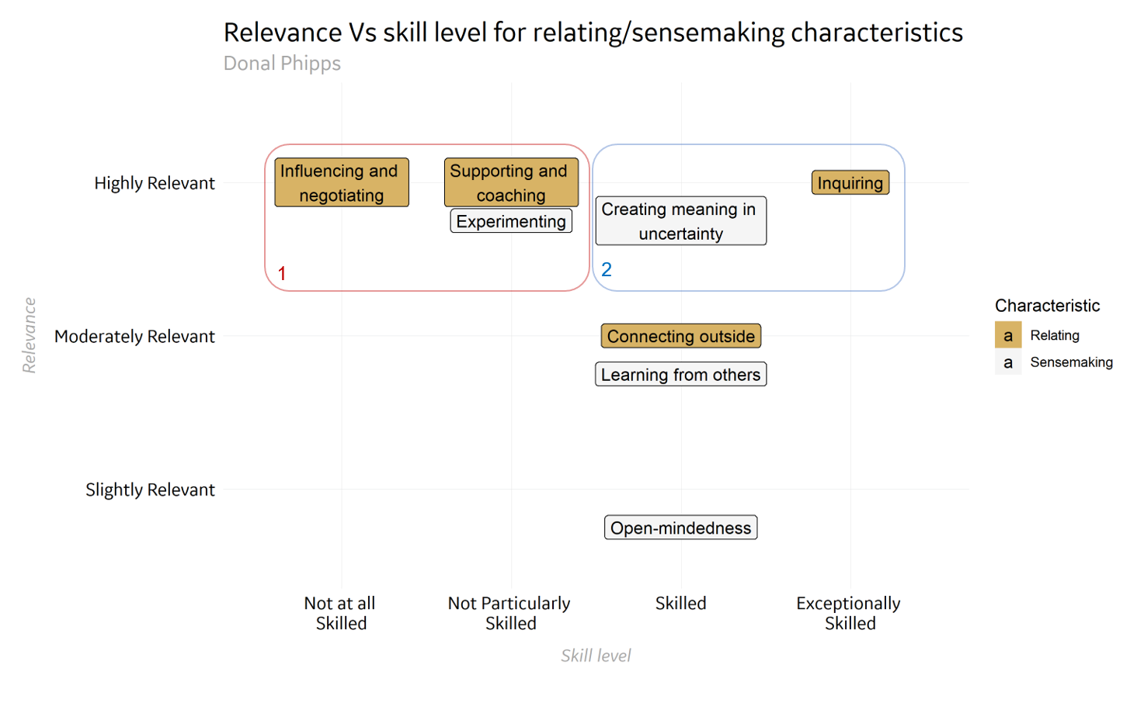

Figure 1

Figure1, above indicates 5 sub-dimensions which are identified as “highly relevant” to this activity (y-axis). My perceived skill level is shown on the x-axis. The basis for my perceived skill scores is my interpretation of peer feedback, both formal and informal, during my career.

Box #2 (blue) highlights highly relevant sub-dimensions which I feel are personal strengths.

* Inquiring: I’ll need to understand the motivations, emotions and assumptions of my peers and team which influence this project. I also need to build genuine, trusting relationships with these stakeholders, as exemplified by Dr. Andy Plump of Takeda[2].

**Personal action points**: in April 2020, I will schedule 1:1 time with my team and all stakeholders. I’ll encourage them to talk openly about their perceptions, assumptions, prior experiences and definitions of success for digital marketing. I will seek a second opinion on how I interpret this feedback from the head of digital at Pentland Brands (an external connection) and the CMO of GE BioPharma.

* Creating meaning in uncertainty (Sensemaking): Our marketing organization has no prior experience with integrating a digital marketing technology plan into its operations. I can help to demystify digital marketing by explaining key concepts in plain English, and showing how they are relevant to stakeholder objectives.
* **Personal action points: T**his week,I have asked one of my team to create a digital intranet, which will serve as a central information source, so that everyone in the organization can see the definitions of digital marketing concepts. I’ll also create a short presentation which defines the organizational opportunity in digital marketing and how our digital projects will capitalize on these.

###### Question 2.2

Can you take the lead in every required aspect of sensemaking and relating, or should you reach out to others to complement your leadership? In your answer, consider the following criteria:

* Consider where your weaknesses lie in terms of the sub-dimensions of sensemaking and relating.
* Review whether the sub-dimensions in which you are not as skilled are relevant for your selected organizational challenge or opportunity.
* Explain the sub-dimensions for which you should reach out to others to complement your leadership when addressing your selected organizational challenge or opportunity.
* If you feel that you can take the lead in every required aspect and do not need to reach out to others, explain why this is the case.

(100–150 words)

Start writing here:

Figure 1 also shows box #1 - highly relevant sub-dimensions where my perceived skill level is lower, and I need to collaborate to succeed.

* Supporting and coaching: my team, and our stakeholders, must feel a sense of ownership of this project, since it cannot succeed without their participation.

**My actions**: In April 2020, identify and contact an exceptionally skilled coach to learn and seek advice.

Develop action plans for each team member & stakeholder which is sensitive to their developmental maturity[3].

* Experimenting: As mentioned in question 2.1, this challenge requires new organizational behaviours for GE BioPharma. As such, I should closely monitor what works and what doesn’t as our roadmap is communicated, and adjust our approach as we continue to learn.

**My actions:** Diarise check-in points to objectively measure and appraise progress with my team (e.g. a stakeholder survey to measure stakeholders’ understanding of and perceived value in the roadmap). Agree together any changes we will make.

* Influencing and negotiating: digital marketing channels often compete with more traditional marketing channels (e.g. tradeshows, direct marketing) for resource and strategic marketing focus.

#### 3. Rubric

Your submissions will be reviewed according to the following rubric.

|  |  |  |  |  |
| --- | --- | --- | --- | --- |
|  | **Criteria not met** | **Criteria met** | **Good** | **Exceptional** |
| **Rate sensemaking and relating skills and their relevance for the selected organizational challenge or opportunity  (Question 1)**  *Participant rates their skills in relation to each sensemaking and relating sub-dimension, as well as the relevance of each sensemaking and relating sub-dimension for the selected organizational challenge or opportunity, using the provided table.* | No submission or attempt. | The provided table is populated to a certain degree, but about half of the rows are empty. | The provided table is populated to a certain degree, but some rows are empty. | The provided table is fully populated. |
| **Explain how sensemaking and relating skills can be used for the selected organizational challenge or opportunity  (Question 2.1)**  *Participant explains how they can engage in sensemaking and relating for their selected organizational challenge or opportunity, based on their answers in Question 1. This includes identifying their strengths, reviewing the relevance of the sub-dimensions, and identifying the specific behaviors they can enact.* | No submission or attempt.  OR  The response is not related to the question. | Participant partially explains how they can engage in sensemaking and relating for their selected organizational challenge or opportunity. However, at least one aspect of the answer is irrelevant or inadequately addressed. | Participant adequately explains how they can engage in sensemaking and relating for their selected organizational challenge or opportunity. All relevant aspects are addressed. | Participant perceptively explains how they can engage in sensemaking and relating for their selected organizational challenge or opportunity. All relevant aspects are insightfully addressed. |
| **Explain whether leadership should be complemented by others (Question 2.2)**  *Participant explains the sub-dimensions for which they should reach out to others to complement their leadership, based  on their answers in  Question 1. This includes considering their weaknesses and reviewing the relevance  of the sub-dimensions. Alternatively, participant explains why they are able to take the lead in every required aspect, based on their answers in Question 1.* | No submission or attempt.  OR  The response is not related to the question. | Participant partially explains the sub-dimensions for which they should reach out to others to complement their leadership, or why they can lead in all aspects required. However, at least one aspect of the answer is irrelevant or inadequately addressed. | Participant adequately explains the sub-dimensions for which they should reach out to others to complement their leadership, or why they can lead in all aspects required. All relevant aspects are addressed. | Participant perceptively explains the sub-dimensions for which they should reach out to others to complement their leadership, or why they can lead in all aspects required. All relevant aspects are insightfully addressed. |
| **Structure and logic of writing**  *Submission is clearly and logically structured.* | No submission or attempt. | Submission has some logical structure and is clear enough to comprehend. | Submission is well-structured in terms of logic and clarity. | Submission is exceptionally well-structured in terms of logic and clarity. |

1. Donal Phipps MIT SL M1U3 Ongoing project, submitted 9th March 2020
2. Interview with Dr. Andy Plump, MIT Sloan Leadership in an Exponentially Changing World 2020-02-26, 3.3 https://mitsloan.onlinecampus.getsmarter.com/mod/book/view.php?id=18814&chapterid=8256
3. Kegan, R., 1994